1. Asosiy G‘oya (Value Proposition)
📌 Kimlar uchun?
- Biznes egalari – Marketing/SMM mutaxassislarini topish uchun
- Marketing va SMM mutaxassislari – O‘z xizmatlarini sotish uchun
📌 Qanday muammolarni hal qiladi?
- Bizneslar yaxshi SMM va marketing mutaxassislarini tez topa oladi
- SMM va marketing mutaxassislari ish topish va mijoz jalb qilish imkoniga ega bo‘ladi

2. Asosiy Funksiyalar

🔹 Biznes egalari uchun:
✅ Profil yaratish
✅ Mutaxassislarni izlash va filtr orqali tanlash (mavzu, narx, tajriba bo‘yicha)
✅ Loyihalar joylash (ish e’lonlari, tender tizimi)
✅ Xizmatlarni buyurtma qilish va to‘lovni amalga oshirish
✅ Hisobot va natijalarni kuzatish

🔹 Marketing va SMM mutaxassislari uchun:
✅ Portfolio va xizmatlar joylash
✅ Taklif yuborish (bizneslar joylagan loyihalar uchun)
✅ Xizmatlarni sotish va obunachilar yig‘ish
✅ Sharh va reyting tizimi orqali ishonchlilikni oshirish

🔹 Platforma uchun qo‘shimcha funksiyalar:
✅ Chat va kelishuv tizimi
✅ To‘lov tizimi (escrow) – Ish bajarilgandan keyin to‘lovlar kafolatlanadi
✅ Obuna modeli (bizneslar uchun premium xizmatlar)
✅ Reklama va targ‘ibot xizmatlari

3. Monetizatsiya (Platforma qanday pul ishlaydi?)
💰 1. Komissiya modeli – Har bir bajargan ish uchun platforma 5-10% komissiya oladi
💰 2. Premium obuna – Bizneslar va SMM mutaxassislari uchun maxsus obuna xizmatlari
💰 3. Reklama va homiylik – Katta bizneslar o‘z xizmatlarini targ‘ib qilishi mumkin
💰 4. VIP xizmatlar – Tajribali SMM mutaxassislari premium xizmatlarni taklif qiladi

4. Texnik Yechim (Web-saytni qanday yaratish mumkin?)

🔹 Stack (Texnologiyalar)
✅ Backend: Python (Django) yoki Node.js (Express.js)
✅ Frontend: React yoki Vue.js
✅ Ma’lumotlar bazasi: PostgreSQL yoki MySQL
✅ To‘lov tizimi: Stripe yoki PayPal integratsiyasi

🔹 Tayyor Yeşimlar
Agar tezroq MVP (Minimal Viable Product) chiqarishni xohlasangiz:
✅ WordPress + Freelancer Marketplace plugin
✅ Bubble.io – kodsiz platforma
✅ Sharetribe – marketplace yaratish uchun tayyor yechim

5. Marketing va Mijoz Topish Strategiyasi
📢 1. Ijtimoiy tarmoqlarda reklama (Facebook Ads, Instagram Ads, TikTok)
📢 2. SEO optimizatsiya (Google’da yuqori reytingga chiqish)
📢 3. YouTube va Blog marketing (SMM, marketing bo‘yicha kontent yaratish)
📢 4. Referral va hamkorlik dasturi (SMM’chilar o‘z xizmatlarini olib kirish uchun bonuslar)
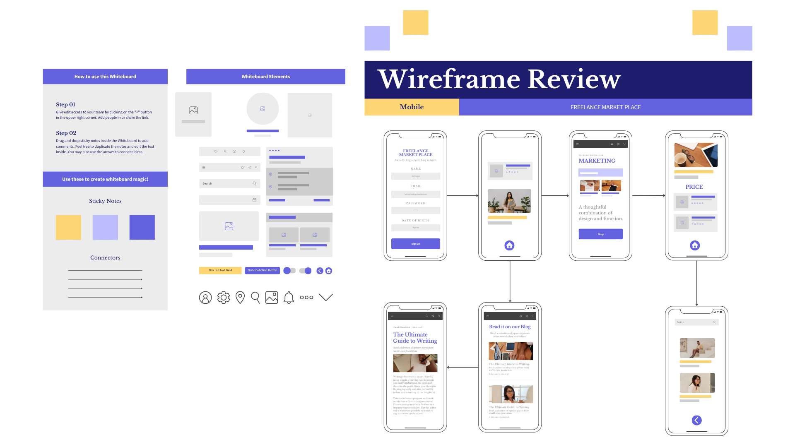

Marketing va SMM Freelancer Platformasi – ERD Diagrammasi

Entities (Jadvalalar):
📌 Users (Foydalanuvchilar)
- user_id (PK)
- full_name
- email (Unique)
- password_hash
- user_type (freelancer/business_owner)
- created_at
📌 Profiles (Profil ma'lumotlari)
- profile_id (PK)
- user_id (FK)
- bio
- skills
- rating
- experience
📌 Projects (Loyihalar)
- project_id (PK)
- owner_id (FK - Users)
- title
- description
- budget
- status (open/in_progress/completed)
- created_at
📌 Proposals (Takliflar)
- proposal_id (PK)
- project_id (FK - Projects)
- freelancer_id (FK - Users)
- price
- proposal_text
- status (pending/accepted/rejected)
- created_at
📌 Services (Xizmatlar)
- service_id (PK)
- freelancer_id (FK - Users)
- title
- description
- price
- created_at
📌 Transactions (To‘lovlar)
- transaction_id (PK)
- payer_id (FK - Users)
- receiver_id (FK - Users)
- amount
- service_id (FK - Services)
- status (pending/completed/failed)
- created_at
📌 Reviews (Sharhlar va reytinglar)
- review_id (PK)
- reviewer_id (FK - Users)
- reviewed_id (FK - Users)
- rating (1-5)
- review_text
- created_at

Relationships (Aloqalar)
- Users ↔ Profiles (1-to-1)
  - Har bir foydalanuvchiga bitta profil bog‘lanadi.
- Users ↔ Projects (1-to-M)
  - Bir foydalanuvchi bir nechta loyiha yaratishi mumkin.
- Users ↔ Proposals (1-to-M)
  - Freelancer bir nechta loyihaga taklif berishi mumkin.
- Users ↔ Services (1-to-M)
  - Har bir freelancer bir nechta xizmat taklif qilishi mumkin.
- Users ↔ Transactions (Payer/Receiver)
  - To‘lovlar freelancer va biznes egalari o‘rtasida amalga oshiriladi.
- Users ↔ Reviews (Reviewer/Reviewed)
  - Foydalanuvchilar o‘zaro baho va sharh qoldirishi mumkin.
- Projects ↔ Proposals (1-to-M)
  - Har bir loyihaga bir nechta freelancer taklif berishi mumkin.
- Services ↔ Transactions (1-to-M)
  - Xizmat ko‘rsatish vaqti to‘lov jarayoni bilan bog‘liq.
